### **Christmas Angel Ornament**



Origami Paper Angel and Plain Copy Paper Angel

This Christmas Angel ornament is very easy to make. I designed this as an assisted living activity for people with limited dexterity. The paper is folded and minimal gluing is required.  
  
I have included two versions of this ornament. One using 6 x 6 origami paper. This origami paper is made from rice paper. The other version is with regular copy paper.



Cut an eight-inch piece of thread for the hangar.



Fold the perforations as shown above.



Bend the wings as shown above.



Curve the smaller face tab inward and glue the tab down.



Repeat for the larger halo tab. This tab will be glued on at the opposite side.

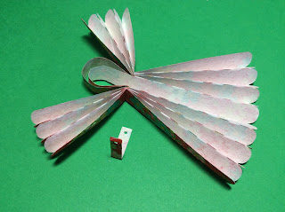

Bend the bodice piece in half and bend it around the body of the angel.

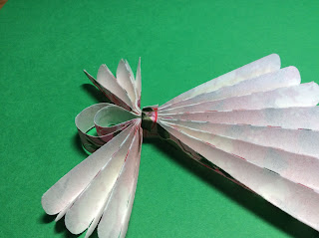

Put a drop of glue on the back of the bodice piece.



Thread the hangar through the hole in the back with a needle. Tie the thread into a knot. (The residents could not do this part so I did it.)



Origami Paper Angel